# **Group Members:**

# **Muhammad Hamza Aziz (FA19-BSE-001)**

# **Ahmad Mujtaba (FA19-BSE-113)**

# **Muhammad Afzan Ahsan (FA19-BSE-053)**

# **Muhammad Abubakar (FA19-BSE-079)**

# **Topics in Software Engineering**

# **Assignment # 01**

Enable the project using any IDE for code review. It would be better to use Eclipse or Netbeans. You may use VS Code too.

1. Explore your project and find all options discussed in lecture 2 from Chapter 2. You need to prepare a google doc that highlights the potential issue  that your code has. You may identify these issues with the help of
   1. **Identify deprecated technology or APIs. Just report the diagram.**

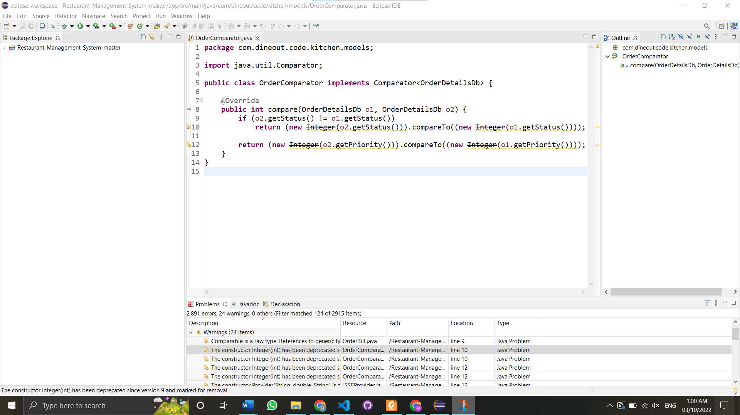

The constructor Integer(int) has been deprecated since version 9 and marked for removal

* 1. **Potential issues missing in the documentation but available in the code**

There are many issues in the code. There is too much abstraction in code. Also, different parameters are declared in the code, but not used after declaring which can cause issues. They have used adapters in many places but in the documentation, it’s missing.

* 1. **missing of technical documentation ( if applicable )**

Not Applicable, SRS is available.

1. Use PMD to help identify potential coding errors and customize the rules you use to make sure only pertinent rules are applied to your source code.
2. **Create & view code issues directly from your editor**

Additems.Java

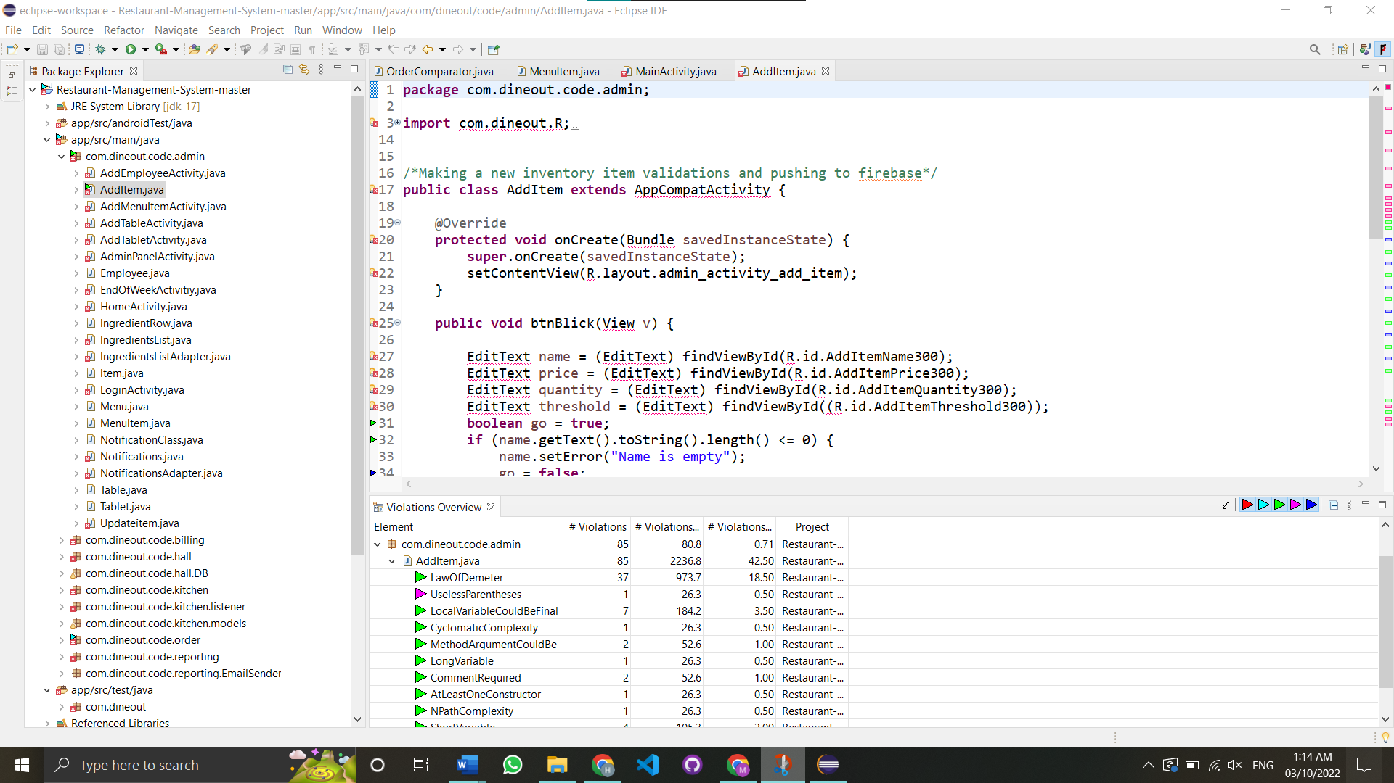

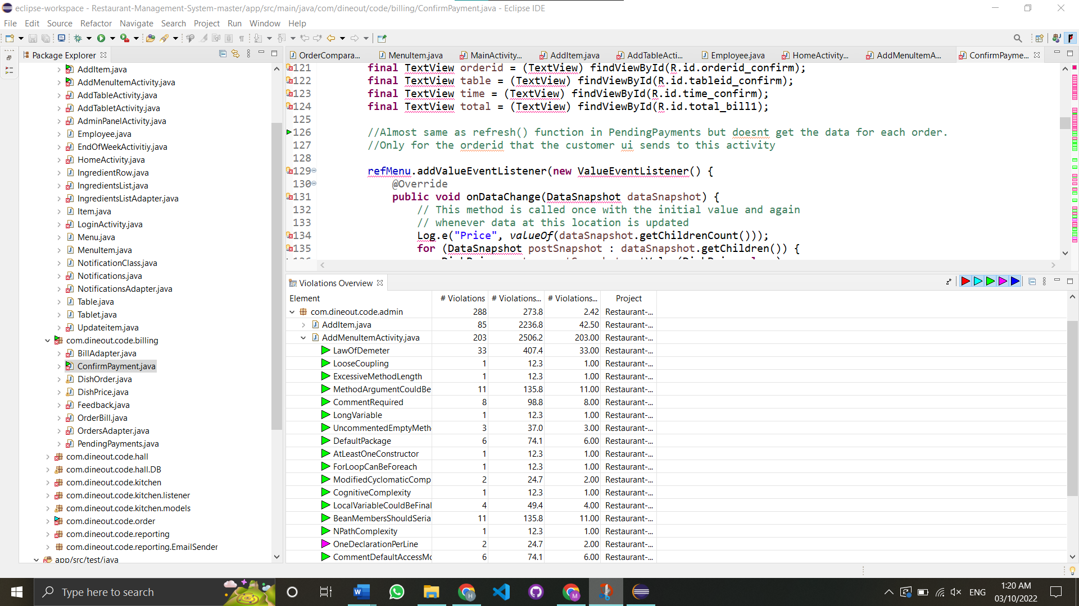

1. **Track & prioritize code improvements like technical debt**

The improvements need to be done are following:

* Field declaration should be at the start of class
* Naming conventions should be followed for classes, methods and variables
* Avoid using short variables
* Unused members and methods should be removed

1. **Check your code quality**

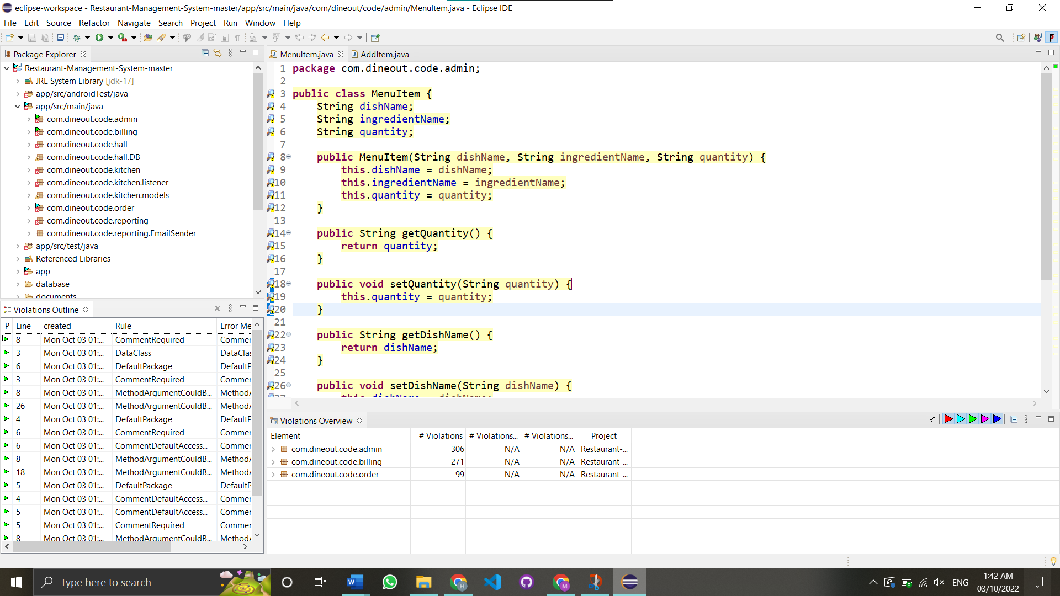

1. **Apply at least 3 PMD rules with the help of tool**

Some PMD rules are:

* OneDeclarationPerLine
* AtLeastOneConstructor
* AvoidDollarSigns
* FieldDeclarationsShouldBeAtStartOfClass
* ControlStatementBrace
* LinguisticNaming

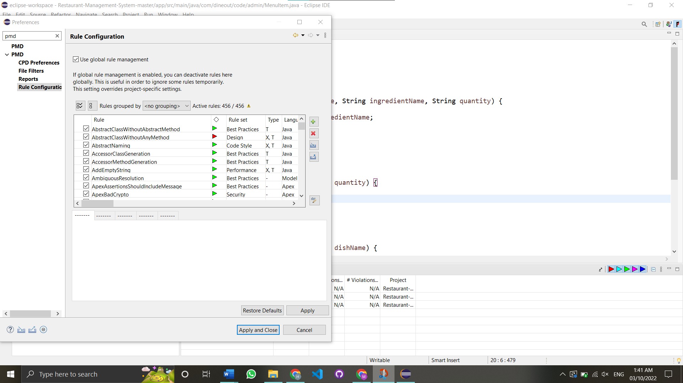

1. Generate the Abstract Syntax Tree of your source code suing PMD.

Abstract syntax tree file generated

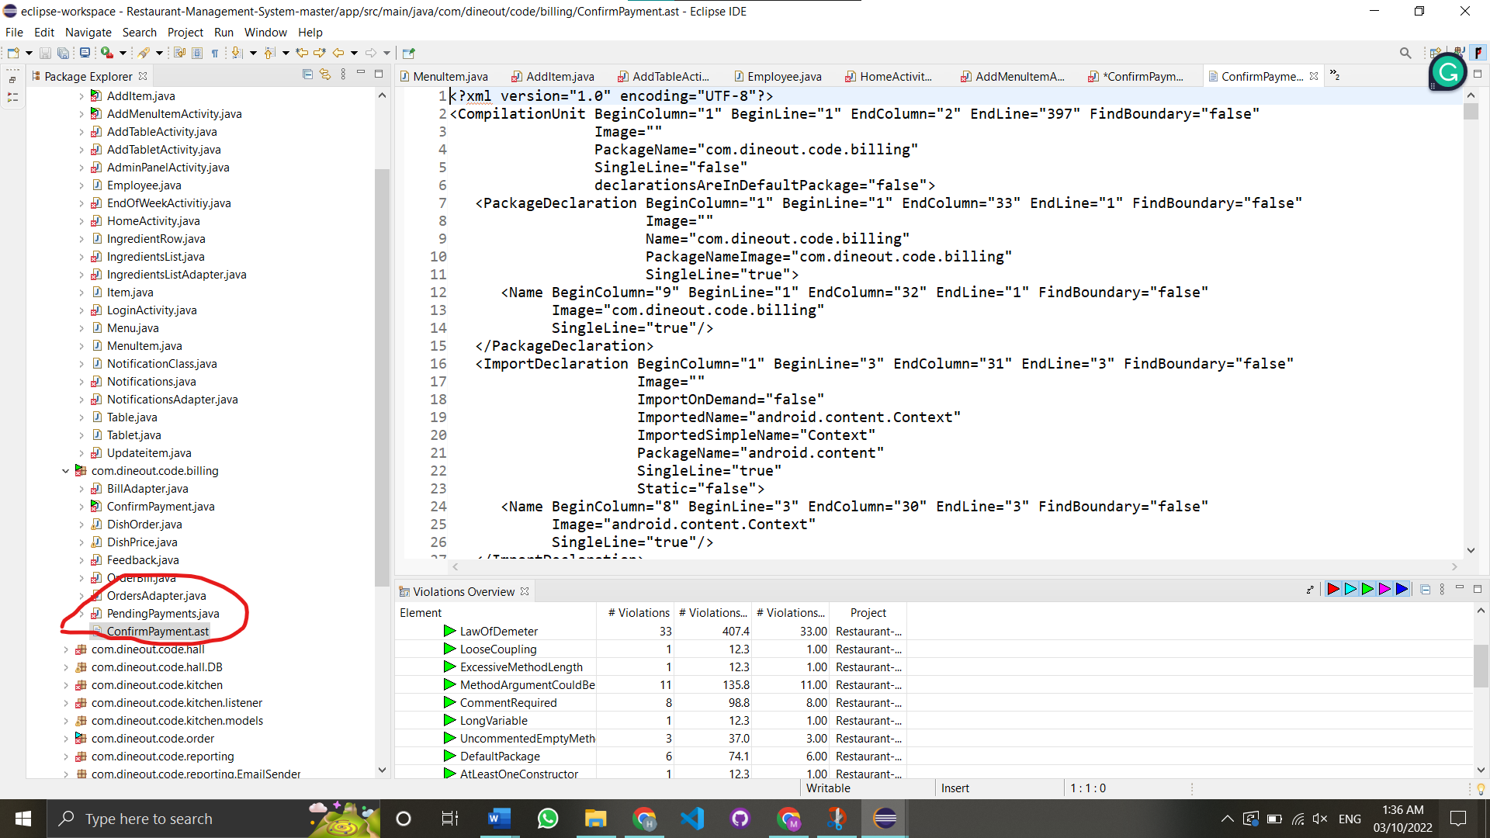

1. **Use the Check Style tool to review your code. At least apply 2 rules on your code using CHeckStyle**

Issues after using checkStyles:

* Missing a Javadoc comment.
* CommentRequired: Class comments are required
* DataClass: The class 'MenuItem' is suspected to be a Data Class
* method def modifier' has incorrect indentation level 4, expected level should be 2.
* MethodArgumentCouldBeFinal: Parameter 'quantity' is not assigned and could be declared final

